

Guide for BMC students:
How to use the BMC Library in person and remotely
1 May 2026
What you can borrow from the library:
- 5 items (books, magazines, DVDs etc) for up to 14 days
- You can renew these items up to 3 times
- Some items are for short loans of 3 days only
- Reference books cannot be removed

Using the self service machine when you are in the Old School Library
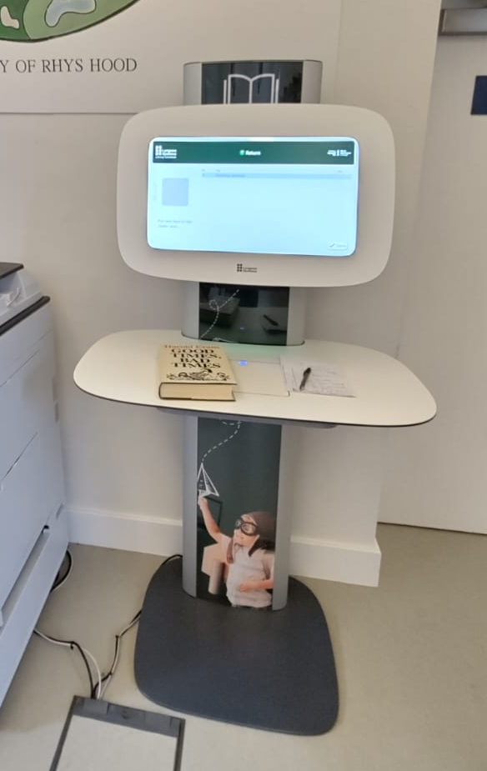
To borrow books or other items and return them, you will need to do this in person at the Old School Library, using the self service machine (located within the library, just to the right of the photocopier).
You can also check the status of your account and renew books this way.
- Choose an action
Press the button for Borrow, Return, My Account, Renew
- Scan your college card
Scan the barcode on your Old School access card – hold it close under the scanner
- Scan your books
If a book won’t scan, check the metallic tag inside the back cover is directly under the scanner
- If you are returning books
The returns box is next to the self service machine
- Press done

Using the Look4 website for remote access
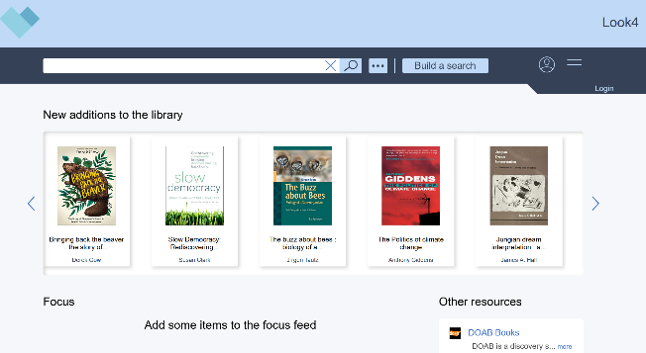
You will need to borrow or return items using the self service machine at the Old School Library - but you can search for and reserve items remotely from the Look4 website:
https://blackm.cirqahosting.com/cirqa-web-app/
You can also access this via the BMC Student Portal, from the top menu on the BMC website: https://blackmountainscollege.uk/

The first time you login to the Look4 website:
- Go to Look4 website: https://blackm.cirqahosting.com/cirqa-web-app/
- Click on Login, at the top right hand corner of the web page
- The first time you login, select the Reset Password option at the bottom of the Login page
- Add your Reader ID (the barcode number on your college access card)
- An email will be sent to the email address associated with your reader record
- From the email, click Reset Your Password, and then enter a secure password twice
- Click Login at the top right hand corner of the Look4 website once more, but this time enter your Reader ID and the new Password – this is how you will sign in each time in future

After logging into Look4 for the first time:
- Go to Look4 website: https://blackm.cirqahosting.com/cirqa-web-app/
- Click on Login, at the top right hand corner of the web page
- Enter:
- Your Reader ID (the barcode number on your college access card)
- Your Password (the one you set the first time you accessed Look4)

If you forget your password:
- Go to Look4 website: https://blackm.cirqahosting.com/cirqa-web-app/
- Click on Login, at the top right hand corner of the web page
- Select the Reset Password option at the bottom of the Login page and follow the instructions that will be emailed to you

Questions
Please send any questions about this document to: library@blackmountainscollege.uk

